ATM MANAGEMENT SYSTEM

## Abstract

The ATM Management System, crafted in C# programming language, represents a robust platform for seamless bank account administration. It encompasses a suite of functionalities tailored to meet the diverse needs of users. Beginning with a visually engaging splash screen, the system ensures an inviting entry point, followed by a secure login authentication process. Users can easily register their accounts, providing essential personal details and establishing authentication credentials. Once authenticated, users gain access to a range of features, including depositing funds, withdrawing cash, and checking balances. Notably, the system offers a Fast Cash feature, enabling users to swiftly withdraw predetermined amounts without manual input. Security is paramount, with users having the option to change PIN numbers to bolster account protection. Additionally, the system generates mini statements, furnishing users with concise summaries of recent transactions for quick reference and reconciliation. Through intuitive design and robust database connectivity, the ATM Management System delivers a seamless banking experience, empowering users to manage their accounts efficiently and securely.

**Introduction:**

In the dynamic landscape of modern banking, technological advancements have revolutionized the way individuals interact with financial institutions. The ATM Management System stands as a testament to this evolution, offering a sophisticated software solution designed to streamline bank account management. Developed using the versatile C# programming language, this system serves as a comprehensive platform catering to the diverse needs of users. With a focus on efficiency, security, and user experience, the ATM Management System provides a suite of functionalities essential for seamless banking operations. From the moment users encounter the visually captivating splash screen to the secure login authentication process, the system aims to deliver an inviting and secure entry point into the banking experience. Through intuitive interfaces and robust database connectivity, users can effortlessly register their accounts, conduct transactions, and monitor their financial activities with ease. This introduction sets the stage for an exploration of the features and benefits offered by the ATM Management System, highlighting its significance in empowering individuals to manage their finances effectively in an increasingly digital world.

**System Overview:**

The ATM Management System is a comprehensive software application developed in C# to facilitate efficient management of bank accounts. It provides users with a seamless and secure platform to perform various banking operations, including account registration, authentication, transaction processing, and account management.

The system begins with a visually appealing splash screen that welcomes users and sets the tone for a user-friendly experience. Upon proceeding, users are presented with a login interface where they can authenticate themselves using unique identifiers such as user IDs, passwords, or PIN numbers.

Once authenticated, users gain access to a range of functionalities tailored to their banking needs. These functionalities include depositing funds into their accounts, withdrawing cash, checking balances, and generating mini statements to review recent transactions.

One of the notable features of the system is the Fast Cash functionality, which allows users to quickly withdraw predefined amounts of cash without the need for manual input. This feature enhances operational efficiency and user convenience.

Additionally, the system prioritizes security by offering users the option to change their PIN numbers, thus ensuring enhanced account protection. All transactions within the system are processed securely, with robust authentication measures and encryption protocols in place to safeguard user data.

Overall, the ATM Management System aims to provide users with a seamless and intuitive banking experience, empowering them to manage their accounts efficiently and securely in today's digital age. With its user-friendly interface, comprehensive functionalities, and emphasis on security, the system stands as a reliable tool for individuals seeking to take control of their financial affairs.

**Key Features of the ATM Management System:**

1. **User Registration**: Allows users to register their accounts within the system by providing personal information and setting up authentication credentials.
2. **Login Authentication**: Secure authentication mechanism ensures that only authorized users can access their accounts, protecting against unauthorized access.
3. **Deposit**: Users can easily deposit funds into their accounts through a straightforward deposit interface, facilitating seamless transactions.
4. **Withdrawal**: Enables users to withdraw cash from their accounts by specifying the desired amount, with accurate transaction processing and balance deduction.
5. **Fast Cash**: Convenient feature allowing users to quickly withdraw predefined amounts of cash without manual input, enhancing operational efficiency.
6. **Change PIN**: Provides users with the option to change their PIN numbers for enhanced security, ensuring greater control over account access.
7. **Balance Inquiry**: Allows users to check their account balances in real-time, providing visibility into their financial status.
8. **Mini Statement**: Generates concise summaries of recent transactions, offering users a quick overview of their account activity for reconciliation and reference.
9. **Security Measures**: Robust security measures, including encryption protocols and authentication mechanisms, safeguard user data and prevent unauthorized access.
10. **User-Friendly Interface**: Intuitive interface design ensures ease of use, making banking operations accessible to users of all levels of technical proficiency.
11. **Database Connectivity**: Utilizes database connectivity to store and retrieve user information securely, ensuring data integrity and reliability.
12. **Transaction History**: Maintains a comprehensive transaction history, allowing users to track and review their past transactions for financial management purposes.
13. **Error Handling**: Implements robust error handling mechanisms to detect and resolve any issues that may arise during transactions, ensuring smooth operation of the system.
14. **Customization Options**: Provides users with customization options to tailor their banking experience according to their preferences and needs.

**Implementation Technologies Used**

* Backend: C#, ASP.NET
* Frontend: Windows Form Designer
* Database: SQL Server
* IDE: Visual Studio 2022 Community Edition

**1.Programs**

**1.1 Login.cs**

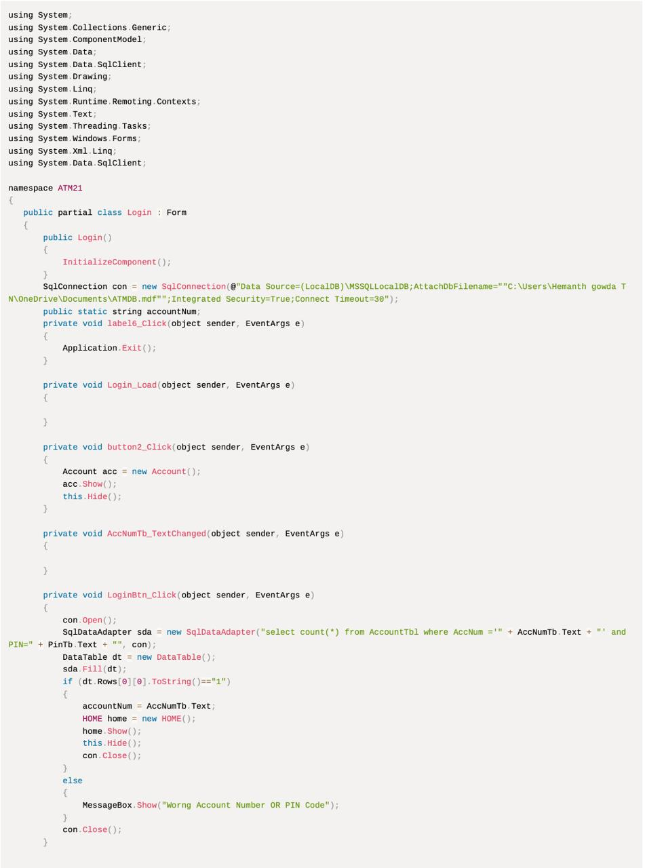

**1.2 Account.cs**

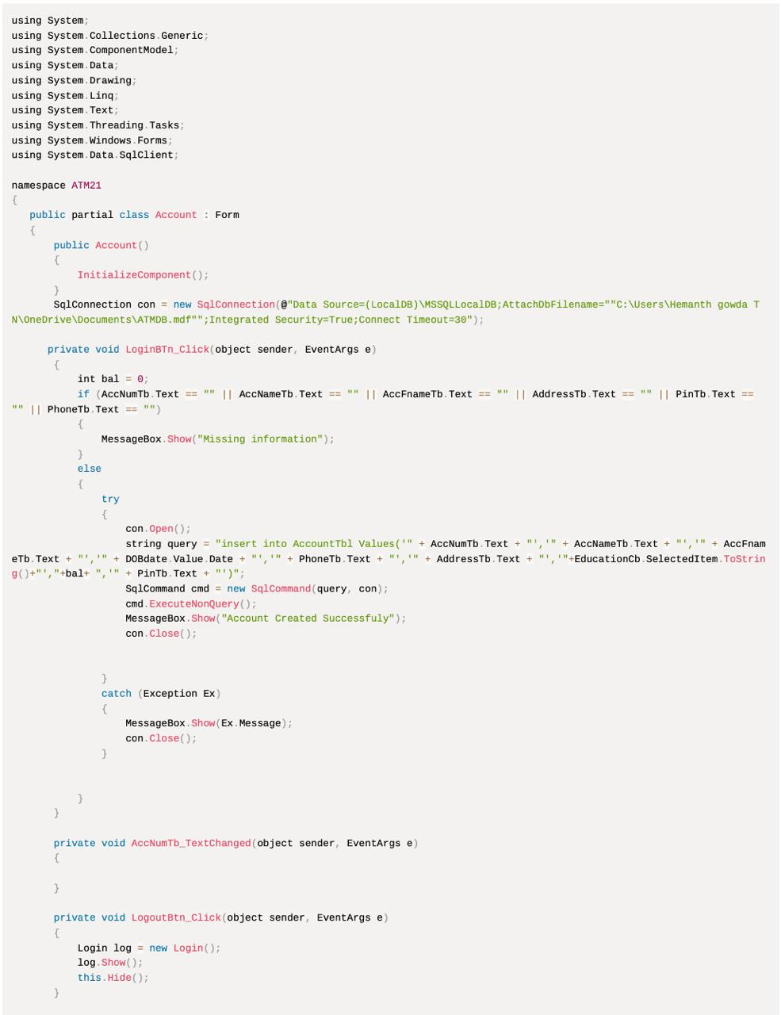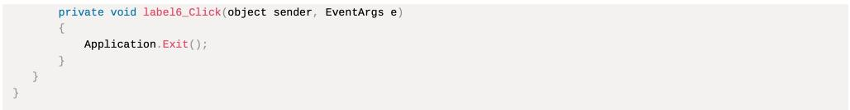

**1.3 Deposit.cs**

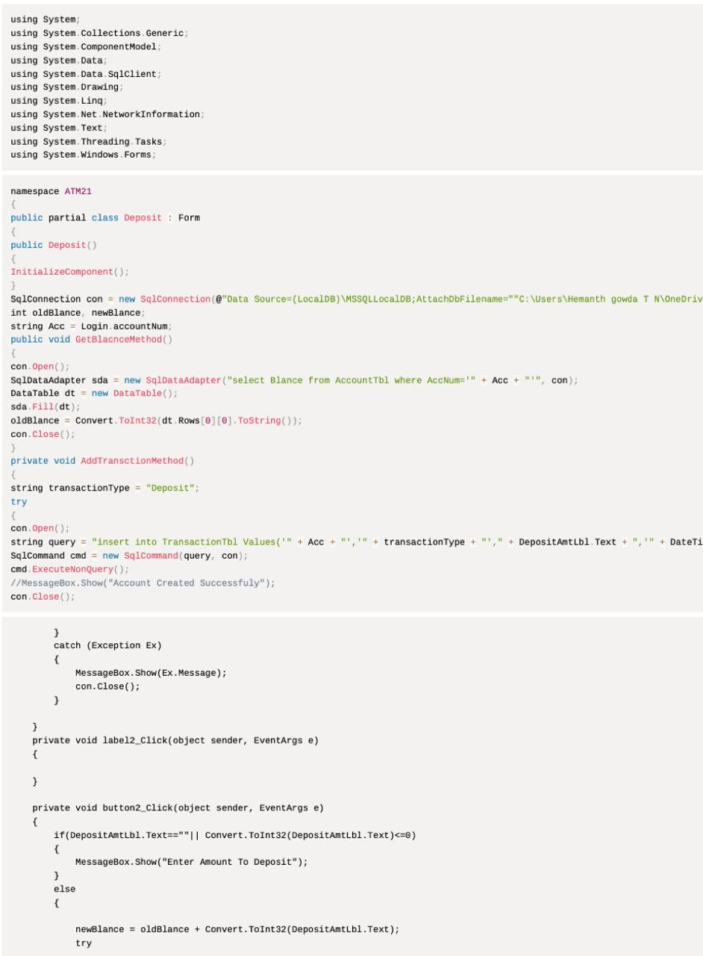

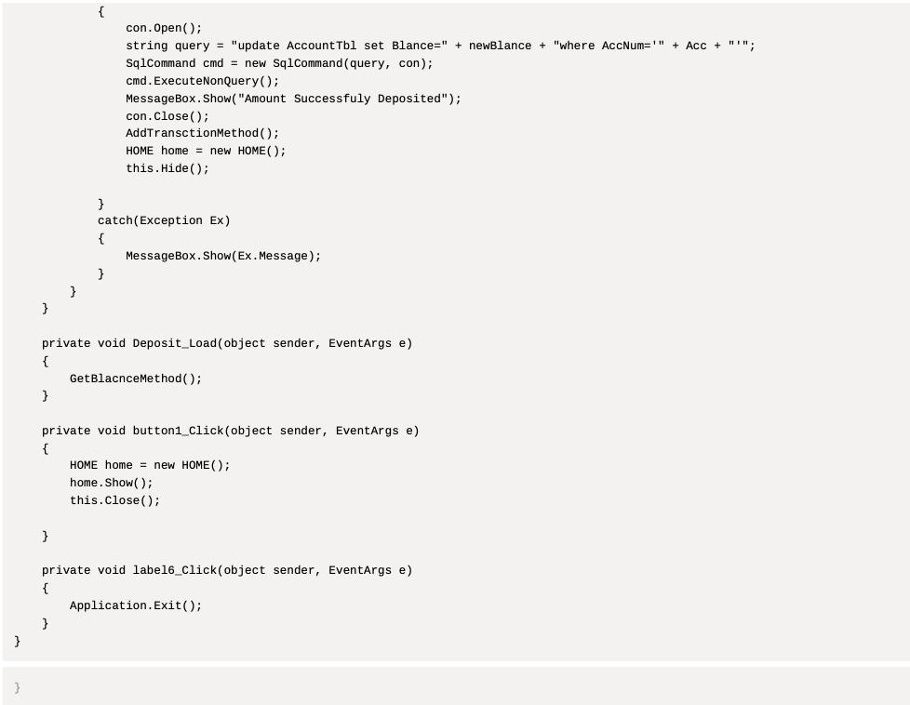

**1.4**  **Withdraw.cs**

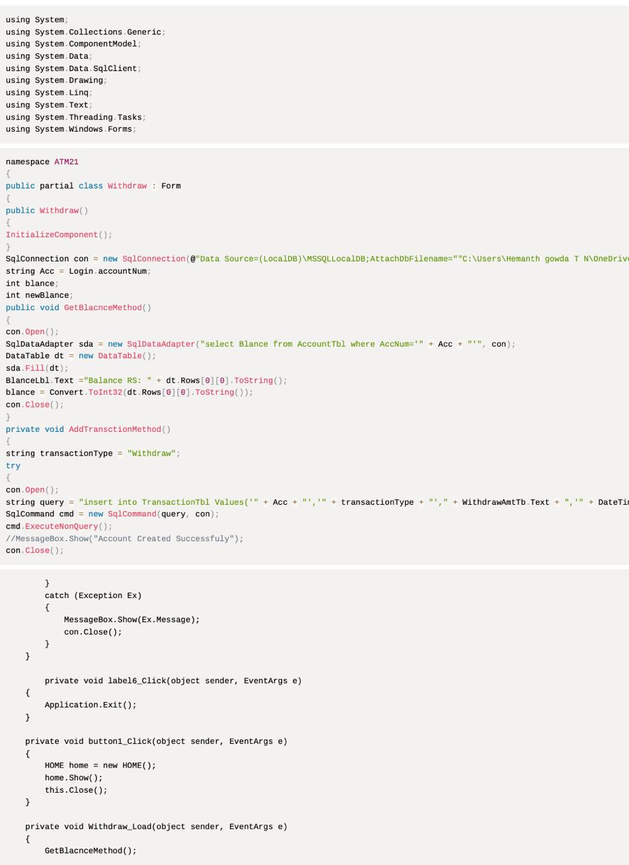

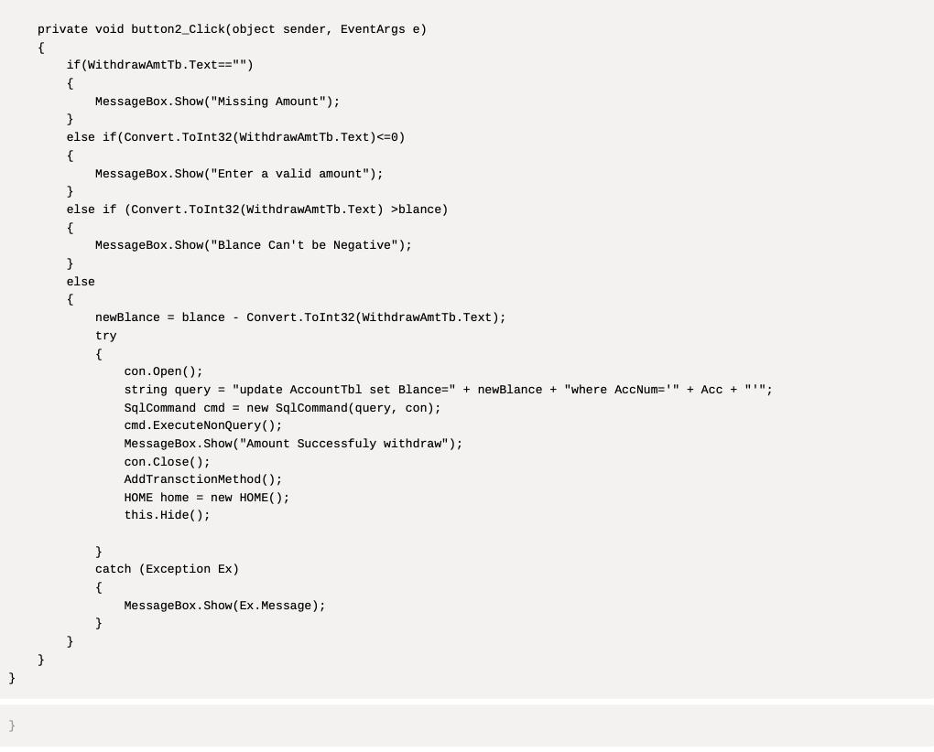

**1.6 MiniStatement.cs**

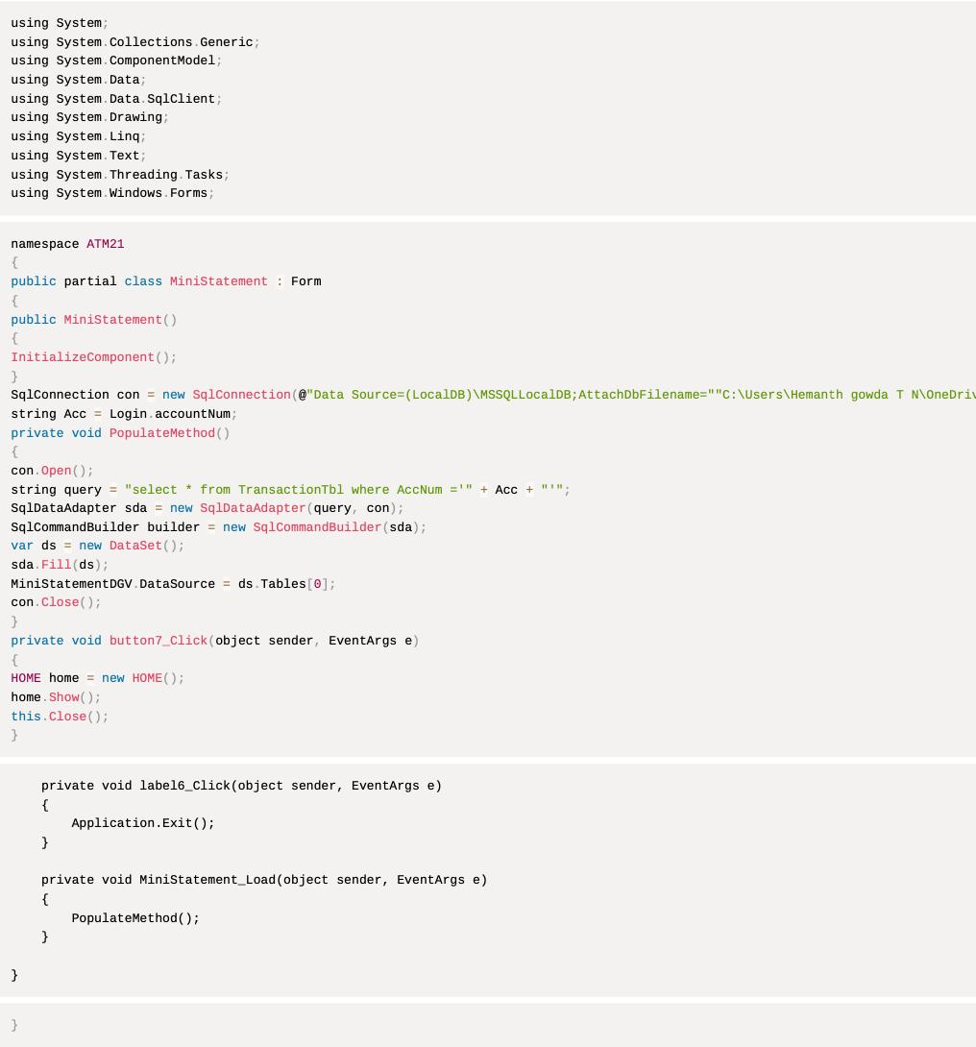

**1.7 ChangePin.cs**

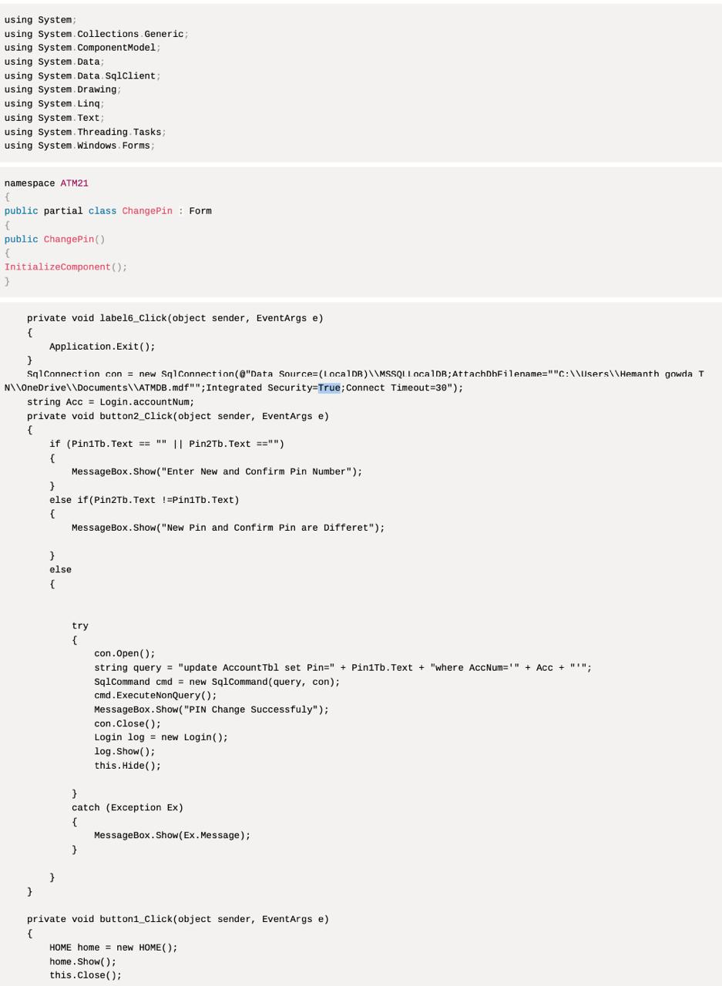

**1.8** **Balance.cs**

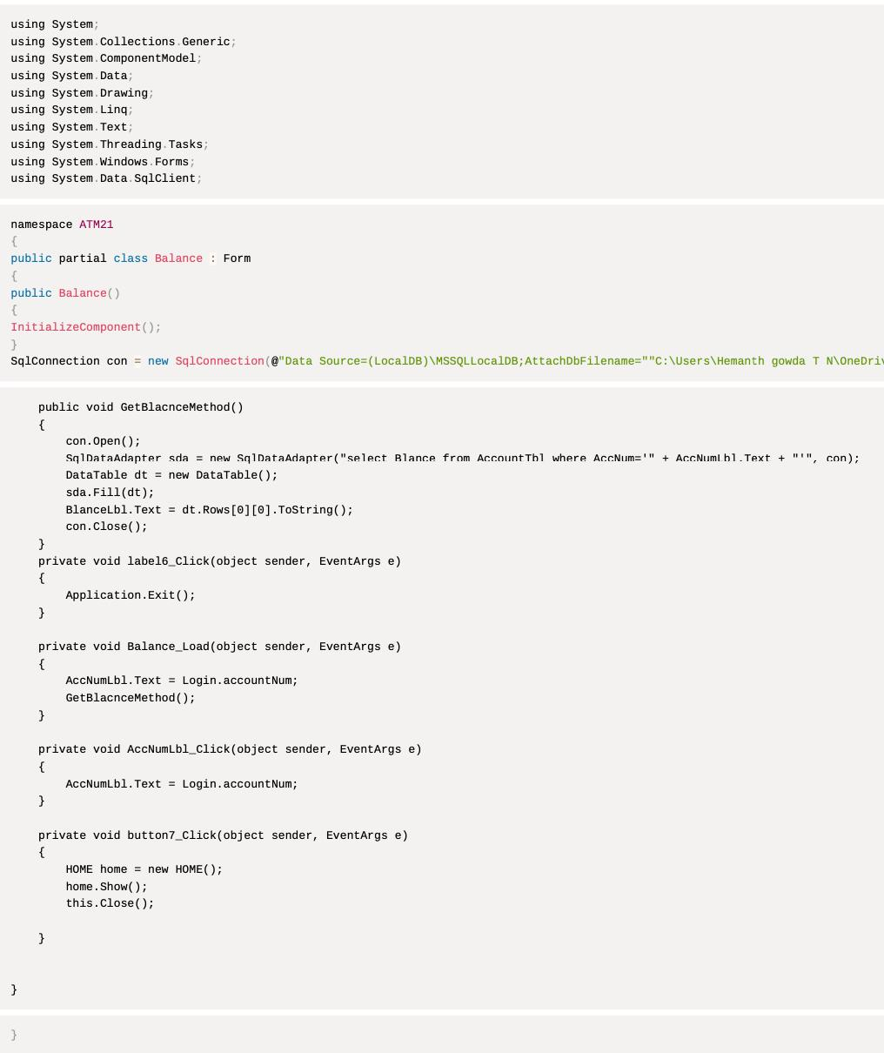

**2.Results**

**2.1Login.cs** 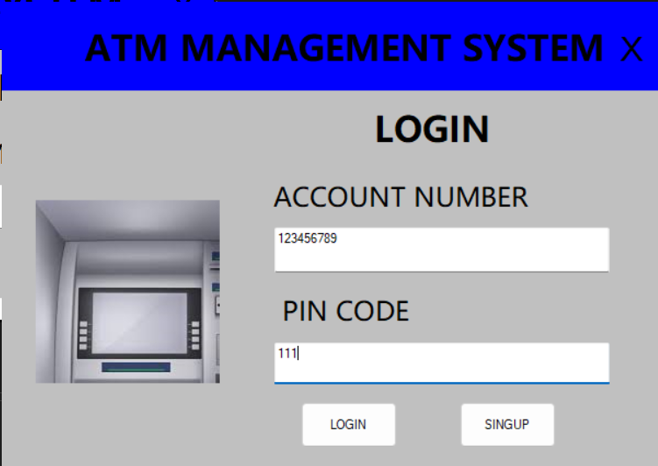

**2.2Account.cs**

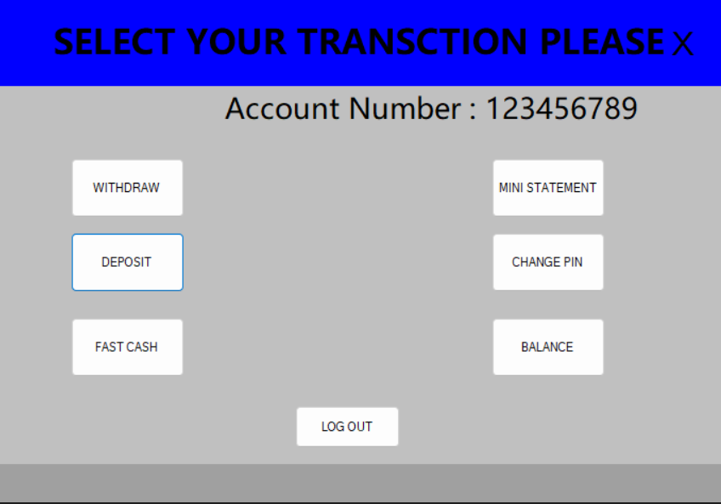

**2.3Deposit.cs**

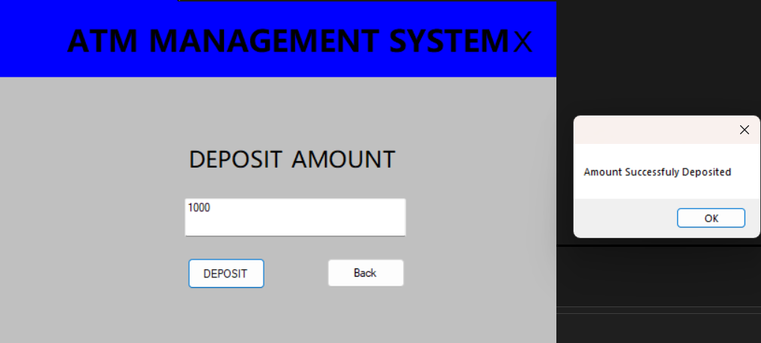

**2.4 Withdraw.cs**

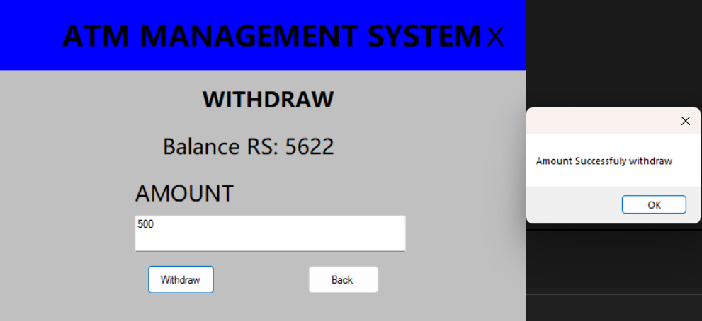

**2.5 FastCash.cs**

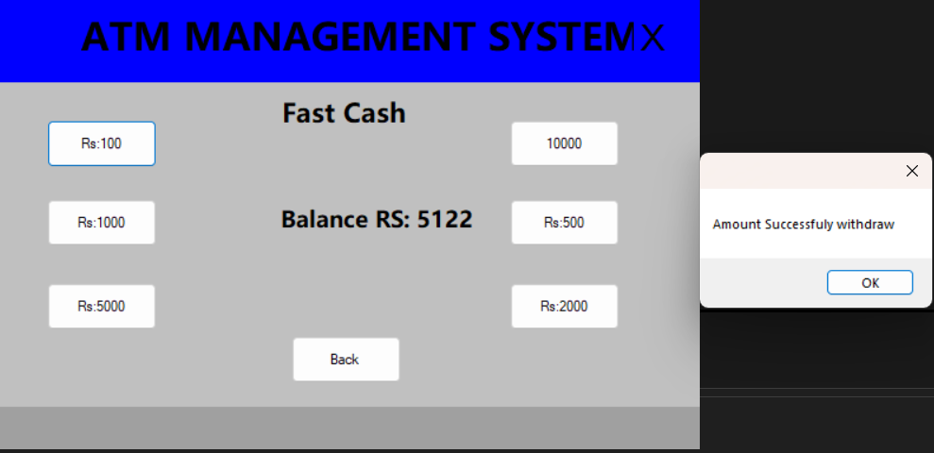

**2.6 MiniStatement.cs**

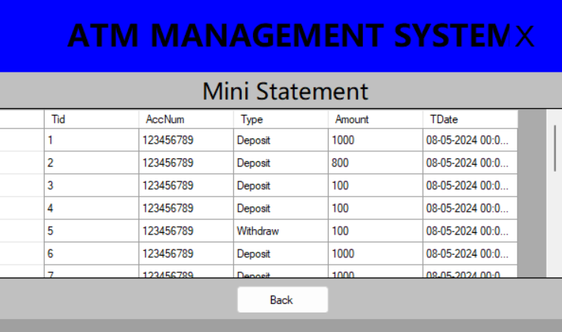

**2.7 ChangePin.cs**

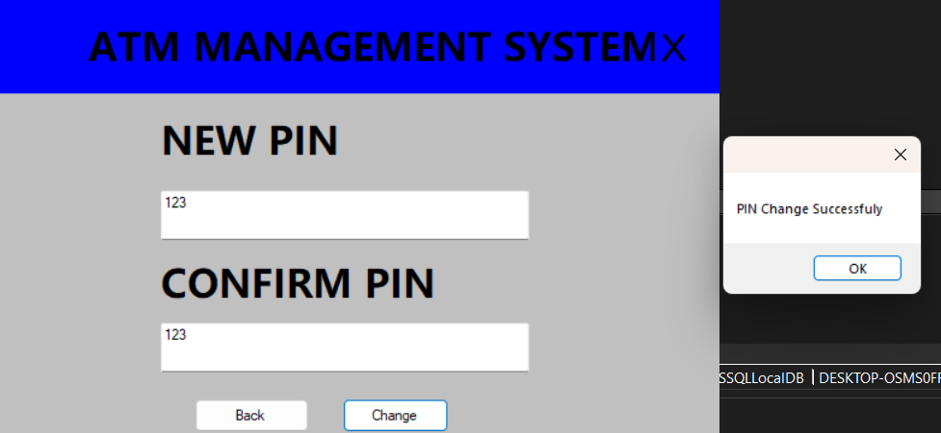

**2.8 Balance.cs**

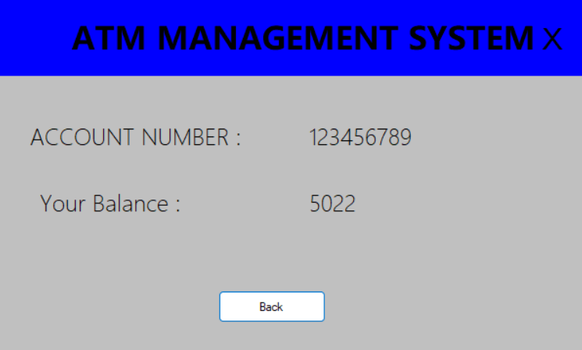

**2.9** **TransactionTbl**

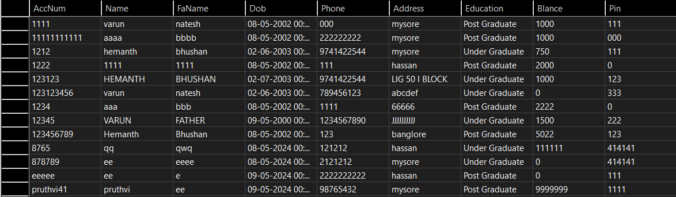

**2.10** **AccountTbl**

